- $$\text{tg}α=\frac{\text{sin}α}{\text{cos}α}$$
- $$\text{ctg}α=\frac{\text{cos}α}{\text{sin}α}$$
- $${\text{cos}}^{2}α+{\text{sin}}^{2}α=1$$
- $$\text{tg}α=\frac{1}{\text{ctg}α}$$
- $$\text{ctg}α=\frac{1}{\text{tg}α}$$
- $$\text{tg}α⋅\text{ctg}α=1$$
- $$1+{\text{ctg}}^{2}α=\frac{1}{{\text{sin}}^{2}α}$$
- $$1+{\text{tg}}^{2}α=\frac{1}{{\text{cos}}^{2}α}$$
9, 10. $\text{sin}(α±β)=\text{sin}α⋅\text{cos}β∓\text{cos}α⋅\text{sin}β$
11, 12. $\text{cos}(α±β)=\text{cos}α⋅\text{cos}β∓\text{sin}α⋅\text{sin}β$
13, 14. $\text{ctg}(α±β)=\frac{\text{ctg}α⋅\text{ctg}β∓1}{\text{ctg}β±\text{ctg}α}$
15, 16. $\text{tg}(α±β)=\frac{\text{tg}α±\text{tg}β}{1∓\text{tg}α⋅\text{tg}β}$
17. $\text{sin}2α=2\text{sin}α⋅\text{cos}α$
18. $\text{cos}2α=1−2{\text{sin}}^{2}α$
19. $\text{cos}2α=2{\text{cos}}^{2}α−1$
20. $\text{cos}2α={\text{cos}}^{2}α−{\text{sin}}^{2}α$
21. $\text{sin}3α=3\text{sin}α−4{\text{sin}}^{3}α$
22. $\text{sin}4α=8{\text{cos}}^{3}α⋅\text{sin}α−4\text{cos}α⋅\text{sin}α$
23. $\text{cos}3α=4{\text{cos}}^{3}α−3\text{cos}α$
24. $\text{cos}4α=8{\text{cos}}^{4}α−8{\text{cos}}^{2}α+1$
25. $\text{tg}2α=\frac{2\text{tg}α}{1−{\text{tg}}^{2}α}$
26. $\text{ctg}2α=\frac{\text{ctg}α−1}{2\text{ctg}α}$
27. $\text{tg}3α=\frac{3\text{tg}α−{\text{tg}}^{3}α}{1−3{\text{tg}}^{2}α}$
28. $\text{ctg}3α=\frac{{\text{ctg}}^{3}α−3\text{ctg}α}{3{\text{ctg}}^{2}α−1}$
29. $\text{tg}4α=\frac{4\text{tg}α−4{\text{tg}}^{3}α}{1−6{\text{tg}}^{2}α+{\text{tg}}^{4}α}$
30. $\text{ctg}4α=\frac{{\text{ctg}}^{4}α−6{\text{ctg}}^{2}α+1}{4{\text{ctg}}^{3}α−4\text{ctg}α}$

31. $\text{sin}\frac{α}{2}\text{=+}−\sqrt{\frac{1−\text{cos}α}{2}}$
32. $\text{cos}\frac{α}{2}\text{=+}−\sqrt{\frac{1+\text{cos}α}{2}}$
33, 34. $\text{tg}\frac{α}{2}=\frac{\text{sin}α}{1+\text{cos}α}=\frac{1−\text{cos}α}{\text{sin}α}$
35, 36. $\text{ctg}\frac{α}{2}=\frac{\text{sin}α}{1−\text{cos}α}=\frac{1+\text{cos}α}{\text{sin}α}$
37. $\text{sin}α+\text{sin}β=2\text{sin}\frac{α+β}{2}⋅\text{cos}\frac{α−β}{2}$
38. $\text{sin}α−\text{sin}β=2\text{sin}\frac{α−β}{2}⋅\text{cos}\frac{α+β}{2}$
39. $\text{cos}α+\text{cos}β=2\text{cos}\frac{α+β}{2}⋅\text{cos}\frac{α−β}{2}$
40. $\text{cos}α−\text{cos}β=−2\text{sin}\frac{α+β}{2}⋅\text{sin}\frac{α−β}{2}$
41. $\text{tg}α+\text{tg}β=\frac{\text{sin}(α+β)}{\text{cos}α⋅\text{cos}β}$
42. $\text{tg}α−\text{tg}β=\frac{\text{sin}(α−β)}{\text{cos}α⋅\text{cos}β}$
43. $\text{ctg}α+\text{ctg}β=\frac{\text{sin}(α+β)}{\text{sin}α⋅\text{sin}β}$
44. $\text{ctg}α−\text{ctg}β=\frac{−\text{sin}(α−β)}{\text{sin}α⋅\text{sin}β}$
45. $\text{cos}α+\text{sin}α=\sqrt{2}⋅\text{cos}({\text{45}}^{0}−α)$
46. $\text{cos}α−\text{sin}α=\sqrt{2}⋅\text{sin}({\text{45}}^{0}−α)$
47. $\text{tg}α+\text{ctg}β=\frac{\text{cos}(α−β)}{\text{cos}α⋅\text{sin}β}$
48. $\text{tg}α−\text{ctg}β=\frac{−\text{cos}(α+β)}{\text{cos}α⋅\text{sin}β}$
49. $\text{tg}α−\text{ctg}α=−2\text{tg}2α$
50. $1+\text{cos}α=2{\text{cos}}^{2}\frac{α}{2}$
51. $1−\text{cos}α=2{\text{sin}}^{2}\frac{α}{2}$
52. $1+\text{sin}α=2{\text{cos}}^{2}({\text{45}}^{0}−\frac{α}{2})$
53. $1−\text{sin}α=2{\text{sin}}^{2}({\text{45}}^{0}−\frac{α}{2})$

54. ${\text{sin}}^{2}α=\frac{1−\text{cos}2α}{2}$
55. ${\text{sin}}^{3}α=\frac{1}{4}(3\text{sin}α−\text{sin}3α)$
56. ${\text{cos}}^{2}α=\frac{1+\text{cos}2α}{2}$
57. ${\text{cos}}^{3}α=\frac{1}{4}(\text{cos}3α+3\text{cos}α)$
58. ${\text{sin}}^{4}α=\frac{1}{8}(\text{cos}4α−4\text{cos}2α+3)$
59. ${\text{cos}}^{4}α=\frac{1}{8}(\text{cos}4α+4\text{cos}2α+3)$
60. $\text{sin}α⋅\text{cos}β=\frac{1}{2}(\text{sin}(α+β)+\text{sin}(α−β))$
61. $\text{cos}α⋅\text{cos}β=\frac{1}{2}(\text{cos}(α+β)+\text{cos}(α−β))$
62. $\text{sin}α⋅\text{sin}β=\frac{1}{2}(\text{cos}(α−β)−\text{cos}(α+β))$
63. $\text{arcsin}x=−\text{arcsin}(−x)=\frac{π}{2}−\text{arccos}x=\text{arctg}\frac{x}{\sqrt{1−x^{2}}}$
64. $\text{arccos}x=π−\text{arccos}(−x)=\frac{π}{2}−\text{arcsin}x=\text{arcctg}\frac{x}{\sqrt{1−x^{2}}}$
65. $\text{arcctgx}=−\text{arctg}(−x)=\frac{π}{2}−\text{arcctgx}=\text{arcsin}\frac{x}{\sqrt{1+x^{2}}}$
66. $\text{arcctgx}=π−\text{arcctg}(−x)=\frac{π}{2}−\text{arctgx}=\text{arccos}\frac{x}{\sqrt{1+x^{2}}}$
67. $\text{arcsin}(−x)=−\text{arcsin}x$
68. $\text{arccos}(−x)=π−\text{arccos}x$
69. $\text{arctg}(−x)=−\text{arctgx}$
70. $\text{arcctg}(−x)=π−\text{arctgx}$
71. $\text{cos}α=\frac{1−{\text{tg}}^{2}\frac{α}{2}}{1+{\text{tg}}^{2}\frac{α}{2}}$
72. $\text{sin}α=\frac{2\text{tg}\frac{α}{2}}{1+{\text{tg}}^{2}\frac{α}{2}}$
73. $\begin{aligned}\text{sin}x=a;\left|a\right|<1 \\ x=(−1)^{n}\text{arcsin}a+πn,n∈Ζ\end{aligned}$
74. $\begin{aligned}\text{cos}x=a;\left|a\right|<1 \\ x=±\text{arccos}a+2πn,n∈Ζ\end{aligned}$
75. $\begin{aligned}\text{tgx}=a \\ x=\text{arctga}+πn,n∈Ζ\end{aligned}$
76. $\begin{aligned}\text{ctgx}=a \\ x=\text{arcctga}+πn,n∈Ζ\end{aligned}$

77. $\begin{aligned}\text{при}\left|a\right|≤1 \\ 0≤\text{arccos}a≤π \\ \text{cos}(\text{arccos}a)=a \\ \end{aligned}$
78. $\begin{aligned}\text{при}\left|a\right|≤1 \\ −\frac{π}{2}≤\text{arcsin}a≤\frac{π}{2} \\ \text{sin}(\text{arcsin}a)=a \\ \end{aligned}$
79. $\begin{aligned}\text{при}∀a \\ −\frac{π}{2}<\text{arctga}<\frac{π}{2} \\ \text{tg}(\text{arctga})=a \\ \end{aligned}$
80. $\begin{aligned}\text{при}∀a \\ 0<\text{arcctga}<π \\ \text{сtg}(\text{arcctga})=a \\ \end{aligned}$
81. $\text{arcsin}a+\text{arccos}a=\frac{π}{2}$
82. $\text{arctga}+\text{arcctga}=\frac{π}{2}$
83. $\begin{aligned}\text{sin}x=0 \\ x=πn,n∈Ζ\end{aligned}$

84. $\begin{aligned}\text{cos}x=0 \\ x=\frac{π}{2}+πn,n∈Ζ\end{aligned}$

85. $\begin{aligned}\text{sin}x=1 \\ x=\frac{π}{2}+2πn,n∈Ζ\end{aligned}$

86. $\begin{aligned}\text{cos}x=1 \\ x=2πn,n∈Ζ\end{aligned}$

87. $\begin{aligned}\text{arcsin}x=a \\ −\frac{π}{2}≤a≤\frac{π}{2} \\ x=\text{sin}a\end{aligned}$

88. $\begin{aligned}\text{arccos}x=a \\ 0≤a≤π \\ x=\text{cos}a\end{aligned}$

89. $\begin{aligned}\text{arctgx}=a \\ −\frac{π}{2}<a<\frac{π}{2} \\ x=\text{tga}\end{aligned}$

90. $\begin{aligned}\text{arcctgx}=a \\ 0≤a≤π \\ x=\text{ctga}\end{aligned}$

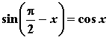, 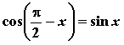, 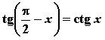, 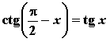,
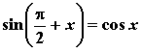, 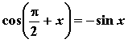, 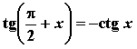, 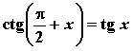,
, , , ,
, , , ,
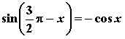, 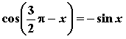

, 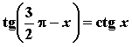,
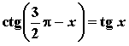,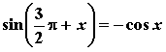, 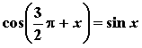,
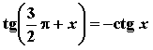, 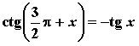.
(a+b)²=a²+2ab+b²
(a-b)²=a²-2ab+b²
(a+b)(a-b)=a²-b²
(a+b)³=a³+3a²b+3ab²+b³
(a-b)³=a³-3a²b+3ab²-b³
(a+b)(a²-ab+b²)=a³+b³
(a-b)(a²+ab+b²)=a³-b³

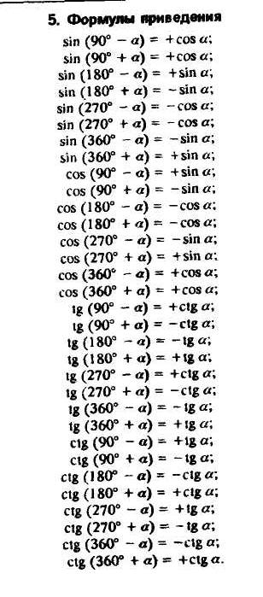
 | I | II | III | IV
sin | + | + | − | −
cos | + | − | − | +
tg | + | − | + | −
ctg | + | − | + | −
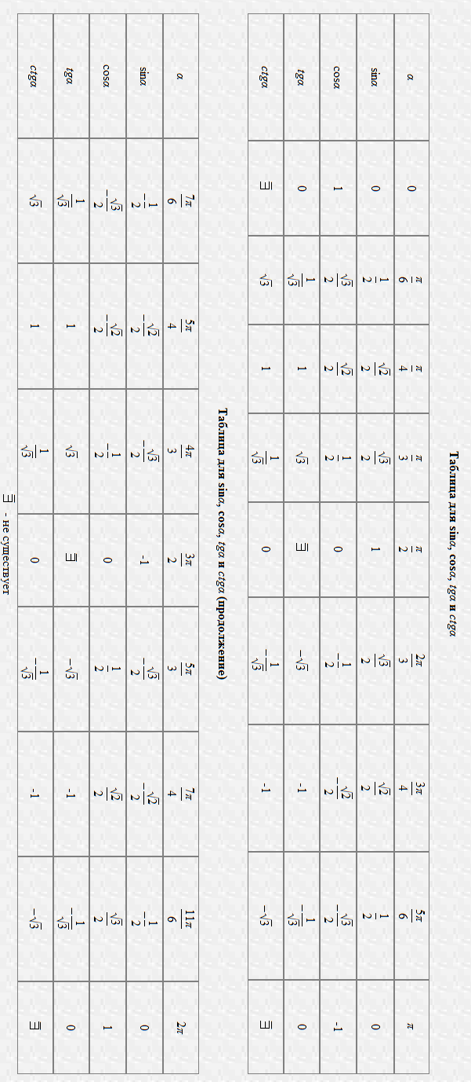

Чётность
Косинус и секанс — чётные. Остальные четыре функции — нечётные, то есть:

Периодичность
Функции y = sin α, y = cos α, y = sec α, y = cosec α — периодические с периодом 2π. Функции: y = tg α, y = ctg α — c периодом π
Если принять любой угол I четверти за , то можно найти значения тригонометрических функций углов всех остальных четвертей по следующей схеме:
для II четверти: все углы этой четверти вычисляются по формуле 180− и используются соотношения
- sin(180−)=sin;
- cos(180−)=−cos;
- tg(180−)=−tg;
- ctg(180−)=−ctg.
для III четверти: все углы этой четверти вычисляются по формуле 180+ и используются соотношения
- sin(180+)=−sin;
- cos(180+)=−cos;
- tg(180+)=tg;
- ctg(180+)=ctg.
для IV четверти: все углы этой четверти вычисляются по формуле 360− и используются соотношения
- sin(360−)=−sin;
- cos(360−)= cos ;
- tg(360−)=−tg;
- tg(360−)=−tg.

